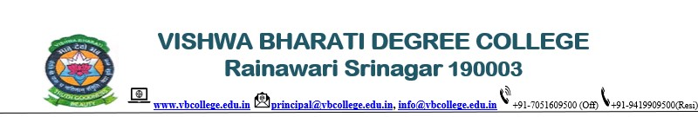

**IMPORTANT NOTICE**

Due to the Technical & maintenance issues of our official website Domain <vbcollege.edu.in>, Our both Official Emails are suspended till their perfect Restoration. Therefore, all our Official communications and correspondence will be carried through the following emails:

1. <[principalvbc@hotmail.com](mailto:info@vbcollege.edu.in)> (for Official)

2. <[vbcollege@hotmail.com](mailto:info@vbcollege.edu.in)>   (for Commercial & Bills)

till our Domain mails:

1. [principal@vbcollege.edu.in], and

2. [info@vbcollege.edu.in] are perfectly and fully restored...

Sd/-

Principal

VB Degree College